“Promoting Youth Employment in Remote Areas in Jordan/Job-Jo 598428-EPP-1-2018-JO-EPPKA2-CBHE-JP”

Evaluation of Existing Business Service Network Bureau (BSNB)
Partner name:
BSNB established at (day/month/year) (official copy to be attached+ photo + logo) | 24-12-2014  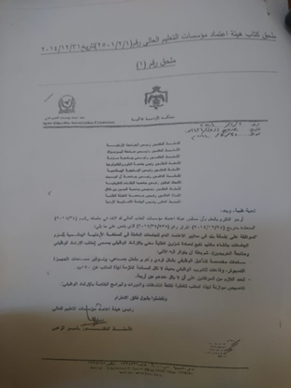  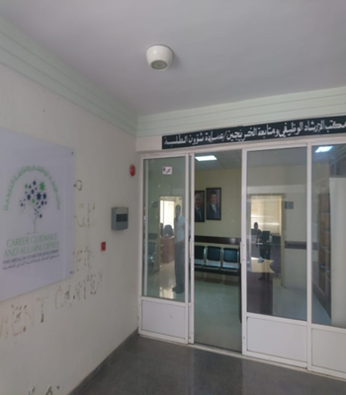
Number of staffs working in BSNB | 3 employees + 1 volunteer
Name of responsible person on (BSNB) | Mr. Basem Majali
E mail of the responsible person and telephone number | bassamjor@yahoo.com
Job description of the responsible person on (BSNB) | Head of the Employment and Follow-up Graduates Division
Is there special Rooms for BSNB | Four offices, a lecture hall and a computer lab
Website of the BSNB or to the project | https://www.facebook.com/kafd.mutah
Is BSNB equipped | yes
What kind of equipment | A lecture hall equipped with benches, tables, a projector and an explanatory board  And a computer lab to give computer courses consisting of 30 devices
Where is the BSNB located at your university | In front of the Deanship of Student Affairs in the administrative and academic complex / first floor
General description of BSNB  To be attached | Building a database of graduates and monitoring the affairs of graduates in their workplaces and with the recruitment agencies, preparing different studies on graduates in the labor market, organizing alumni meetings (graduates' conference, graduates' forums and career exhibition) and obtaining graduates' success stories.  Services provided BSNB:  1- Career extension services.  2. Training services.  3. Activities and partnerships services (networking).  4. Graduate follow-up services.
Total Number of Students | 20,000
Number of total graduates per year | 3450
Number for each faculty
Number of graduates per year/faculty
General description of the activity of BSNB | Services provided BSNB:  1- Career extension services.  2. Training services.  3. Activities and partnerships services (networking).  4. Graduate follow-up services.
Do you have a data base for graduated student? | yes
Do you have a data base for industry? | yes
Do you have any mechanism to follow up graduated student? | Alumni Database:  It is a database that includes information related to name, sex, nationality, date of birth, academic qualification, year of graduation, college, department, current job, country of work, telephone, email.  2. Alumni Conferences:  Annual conferences are held and graduates are invited to increase the link of graduates.  3. Virtual clubs:  These are forums developed by universities in order to increase communication with graduates using social networking issues.
Do you have any training for student? | Yes: Employment skills  (Job search skills, CV preparation skills, letter cover writing, job interview skills, work ethics, labor and labor law, social security law)  Leadership skills and self-employment  (Entrepreneurship, entrepreneurship, business plans, finance, management and financial skills)  communication skills  (Body language, customer service skills, language programming and nervousness)  English  (Writing Skills in English)  Financial analysis using EXCEL  Display POWER POINT  Use MICROSOFT OFFICE  Technical Drawing AUTOCAD  Awareness, Community and Volunteer Programs:  (Democracy, human rights, volunteerism, drugs, extremism, women's rights, children's rights, the rights of persons with disabilities, community service)
Do you have training materials? | Yes
List the name of training courses | (Job search skills, CV preparation skills, letter cover writing, job interview skills, work ethics, labor and labor law, social security law)  Leadership skills and self-employment  (Entrepreneurship, entrepreneurship, business plans, finance, management and financial skills)  communication skills  (Body language, customer service skills, language programming and nervousness)  English  (Writing Skills in English)  Financial analysis using EXCEL  Display POWER POINT  Use MICROSOFT OFFICE  Technical Drawing AUTOCAD  Awareness, Community and Volunteer Programs:  (Democracy, human rights, volunteerism, drugs, extremism, women's rights, children's rights, the rights of persons with disabilities, community service)
Do you have any training for fresh graduated student? | It is the same training courses for students.
Anything to be add | no

