Description of databases
In these databases, every subject was asked to sit on a chair while the tablet was in front of him/her on a table, and asked to write with his/her finger horizontally from right to left (Figure (1)). The researcher created 2 databases; the first with one word, “Mohammed” (محمد) repeated 10 times, and the second database consists of two words, "Mohammad Abdallah" (محمد عبدالله) repeated 10 times on the same tablet. The reason for selecting these words, is that the word “Mohammad” is the most common name in Arabic.

The 200 writers were requested to take a short break of approximately 10 seconds before each trail, so each writer wrote 20 trails in one session.

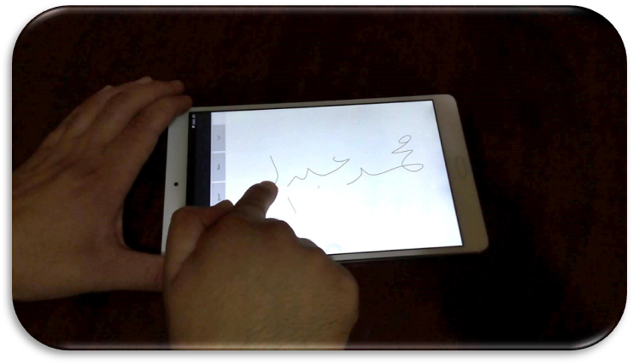
Figure 1: Writing horizontally from right to left

Therefore, each database consists of 2000 samples (10 trails x 200 writers) representing the handwriting of 200 writers (males and females). The ages of the writers is in the range of 9 to 63 years old, and their educational level varies from basic education (school) to Doctoral degree. All writers wrote with their right hand except 6 writers who used their left hand in writing. For both databases, we documented the writer’s age, gender, education level and which hand ( Right or Left) the writer used to write.
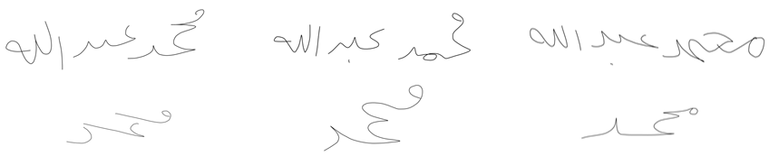
Figure 2: Some samples of six different subjects from the AHWDB1 and AHWDB2

Particularly, both AHWDB1 and AHWDB2 are created for the purpose of identifying the writers from their handwriting. In addition, this dataset might be used for other purposes, such as classifying the writers by their ages, or genders, educational levels, etc. because the current researcher collected and documented the demographic information of each writer. Figure (2) shows some samples of different writers from both AHWDB1 and AHWDB2 datasets.
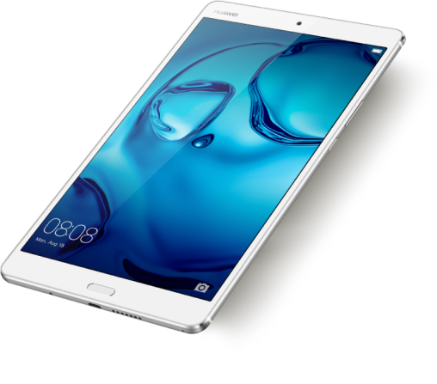
Figure 4: HUAWEI MediaPad M3 (35).
HUAWEI MediaPad M3, which is shown in Figure (4) is the devise used for the acquisition of the handwriting. Specifications of the device are shown in Table (1). A special android application was developed and installed for the acquisition process. The application was user friendly and has the capability of clearing the screen and rewriting when there is a requirement for that process. Moreover, the application was programmed to store the coordinates, timestamp and the pressure of the writer's finger on the screen directly while writing on a notepad file (TXT format), and also an image (JPEG format) of the handwritten word on the screen. Every trail's information (X-coordinate, Y-coordinate, timestamp, pressure) was stored in a text file( as shown in figure (5)) with a name consisting of concatenation of the number of users and their trail number (ex. User 22 and trial 14 (22_14)). However, in this paper the current researchers will focus on the X-coordinate and Y-coordinate information only, leaving other information (pressure and time) for future work.

Timestamp X Y Pressure  20170314151243488,380.0,569.0,0.39607847  20170314151243509,380.8568,570.7136,0.44705886  20170314151243526,383.26846,573.2685,0.4666667  20170314151243543,386.0,579.0,0.47450984  20170314151243560,389.6916,584.5888,0.4784314  20170314151243577,392.51407,591.28516,0.49803925  20170314151243594,394.66257,598.97534,0.5058824  20170314151243611,396.04553,606.2277,0.52156866  . . . .  . . . .  . . . .  . . . . | Timestamp X Y Pressure  20170314151620528,458.0,282.0,0.3803922  20170314151620565,458.0,284.565,0.4901961  20170314151620582,458.0,287.3474,0.5137255  20170314151620599,459.5,293.0,0.5254902  20170314151620617,462.87726,300.69318,0.5372549  20170314151620634,464.3198,308.91876,0.54901963  20170314151620651,466.0,314.8072,0.54901963  20170314151620668,467.08435,320.33746,0.5568628  . . . .  . . . .  . . . .  . . . .
Figure 5: (A) timestamps, X coordinates, Y coordinates and pressure information of trail 6 from subject 195 from the AHWDB1 database. (B) Same information of trail 14 from subject 195 from the AHWDB2 database. (C) An image of (A). (D) an image of (B).

Table 1: HUAWEI MediaPad M3 Specifications (35).

2016, September | Announced | LAUNCH
Available. Released 2016, October | Status
215.5 x 124.2 x 7.3 mm (8.48 x 4.89 x 0.29 in) | Dimensions | BODY
- | Weight
Nano-SIM | SIM
IPS LCD capacitive touchscreen, 16M colors | Type | DISPlAY
8.4 inches, 204.6 cm2 (~76.4% screen-to-body ratio) | Size
1600 x 2560 pixels, 16:10 ratio (~359 ppi density) | Resolution
Yes | Multitouch
-EMUI 4.1
Android 6.0 (Marshmallow) | OS | PLATFORM
Hisilicon Kirin 950 | Chipset
Octa-core (4x2.3 GHz Cortex-A72 & 4x1.8 GHz cortex A53) | CPU
Mali-T880 MP4 | GPU
microSD, up to 256 GB (dedicated slot) | Card slot | MEMORY
32/64 GB, 4GB RAM | Internal

