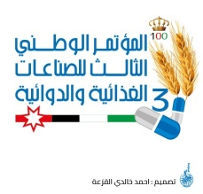 | Third National Conference for Food and Drug Industry (TNCFDI-2021)
May 26-27, 2021, Mutah University, Karak, Jordan
http://mutah.edu.jo/ TNCFDI-2021

Please complete the form and send by e-mail: CFDI2021@mutah.edu.jo
before April 15, 2021.

Conference Abstract Form

Author’s name: | Position:
Organization: | Country:
Mailing address: | Phone no.:

Participation Type: |  | Presentation | Poster
Abstract Title:
Names of additional authors:

Abstract (Maximum of 300 words):

Key words:

For additional information, please contact:

Prof. Adel Abdel-Ghani (E-mail: abdelghani@mutah.edu.jo) (Cell phone: +962‐799771229)

Prof. Marwan Mousa (E-mail: ----@mutah.edu.jo) (Cell phone: +962‐------------).

